“european food adventures”
2019-1-EL01-KA229-062400_1

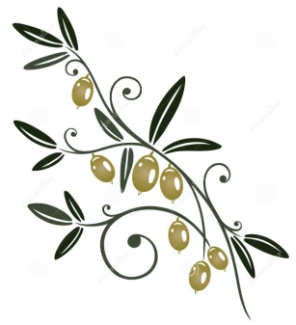 | “THE DAUGHTER OF THE SUN”  LAST MEETING  Organized by the Primary school of ormilia, Greece  30/05/22 - 03/06/22 | 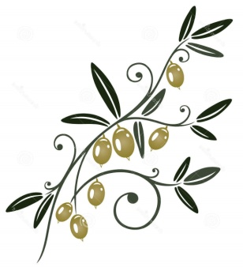

PARTICIPANTS
DIMOTIKO SCHOLEIO TSERIOU 1, Cyprus
Mehmet Çekiç Ortaokulu, Turkey
OSNOVNA SKOLA LUCAC, Croatia
CAES L'AMISTAT, Spain
Agrupamento de Escolas de Barroselas, PORTUGAL

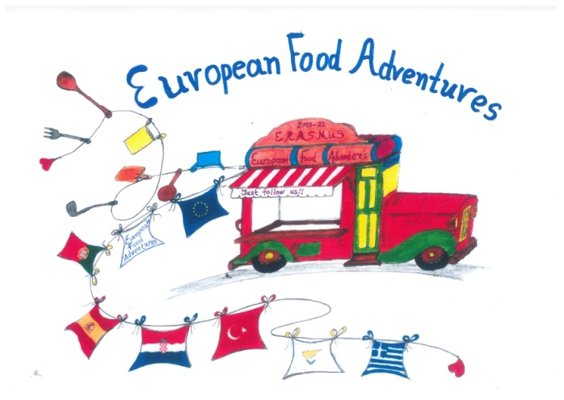
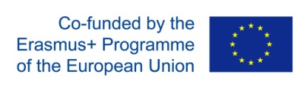

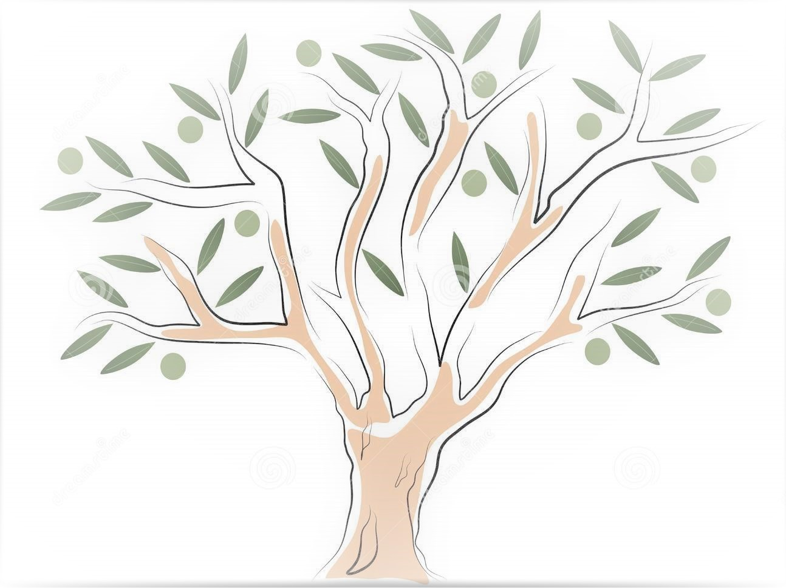
MONDAY  08:30  -Welcoming ceremony at school  -Singing the Erasmus hymn  -Explaining the title of the meeting  -Traditional music and dance  -Getting to know each other activity  -Coffee break  -Teachers’ meeting  -Guiding tour around school by students  1:30 Visiting a beekeeping cooperative  2:30 Lunch in Psakoudia  Back to the hotel, free time | TUESDAY  All day visit to Meteora monasteries  Lunch in Kalambaka village  Late in the evening, back to the hotel, free time | WEDNESDAY  All day trip to Thessaloniki  Visits to:  -Castle walls  -Saint Dimitrios church  -the White Tower of Thessaloniki  -the Archaeological Museum of Thessaloniki  -Lunch  -Cruise to the gulf of Thessaloniki  Back to the hotel, free time | THURSDAY  9:00-18:00  Holly Mount Athos Sea Cruise  Visiting ‘Banana’ beach of Ammouliani Island,  swimming  Lunch on board  18:30 Free time | FRIDAY  8:00 at school  Activities, games, workshops, presentations in school  1:30 Visiting a monastery  Free time for lunch and relax  19:30  Final farewell feast, dinner and presentations

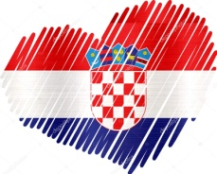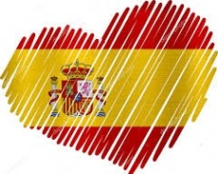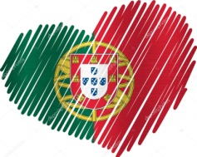

Panagiota Nikita 6974793410

