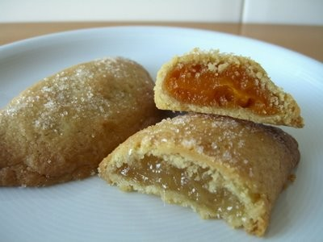
Pastissos de boniato

The Region's most typical Christmas sweet is pastís de moniato (sweet potato pastry). Arabic in origin, they are usually made as small pastries and, therefore, are often referred to in the plural, pastissos. The fusion of flavours between the cinnamon and the sweet potato, with a hint of cazalla aniseed liqueur, is a true celebration for the senses.

Ingredients
For the dough: 1/2 glass of high-alcohol cazalla (aniseed spirit), 1/2 glass of olive oil, 1/2 kg. sugar, 3/4 kg. flour, 1 egg. For the filling: 3/4 kg. white sweet potato, 1/4 kg. sugar, cinnamon.

Preparation
For the filling, boil the sweet potatoes with their skins on. Peel, and scoop the pulp out while still hot and mix with the sugar and a pinch of cinnamon until a thick paste is formed.To make the dough, mix the aniseed spirit and the olive oil together with the sugar in a pot over a low heat. Take care that the high-alcohol spirit does not catch fire. Cover with the lid for a few seconds if it does. When part of the alcohol has evaporated and the sugar has dissolved, add the flour. Mix well to form a paste. This process should last about 20 minutes in all. To make the pastries, the dough should be worked while hot. Spread them out in round portions (using a glass as a mould) on a smooth oiled surface. Fill with the sweet potato paste and close. Seal the ends by crimping with a fork. Brushed over with a beaten egg to achieve a shiny gloss when baked. Place in a pre-heated oven and bake for 25 minutes at 220º.

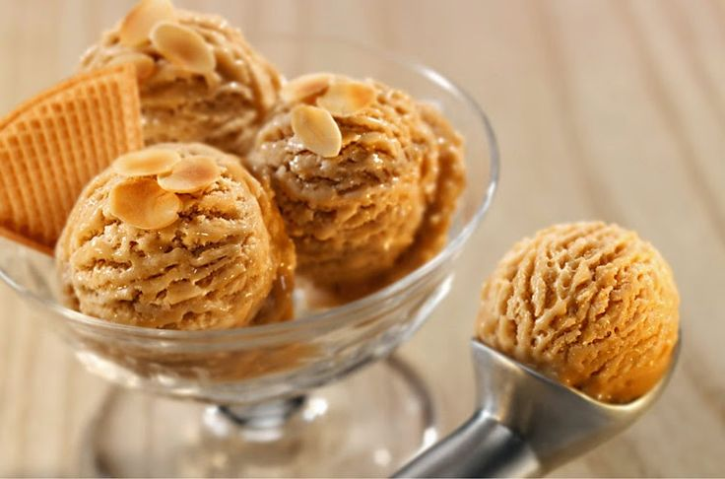
Gelat de torró (Nougat ice cream)
The province of Alicante is the land of ice cream and nougat. If we combine these two delicacies we get one of the most delicious desserts you could ever try, especially during the warm summer months. Nougat, with denomination of origin in Jijona and Alicante, is a delicious sweet typically eaten at Christmas and just as wonderful as an ice cream in summer.

Ingredients
1/2 l. milk, 100 cc fresh cream, 100 gr. sugar, 150 gr. Xixona turrón.

Preparation
Use a knife to slice up the soft turrón. Mix it with the milk, sugar and cream to obtain a paste, neither too soft nor too hard. Leave to stand for over five hours. Tip into an ice-cream dish and freeze until it has the desired consistency.

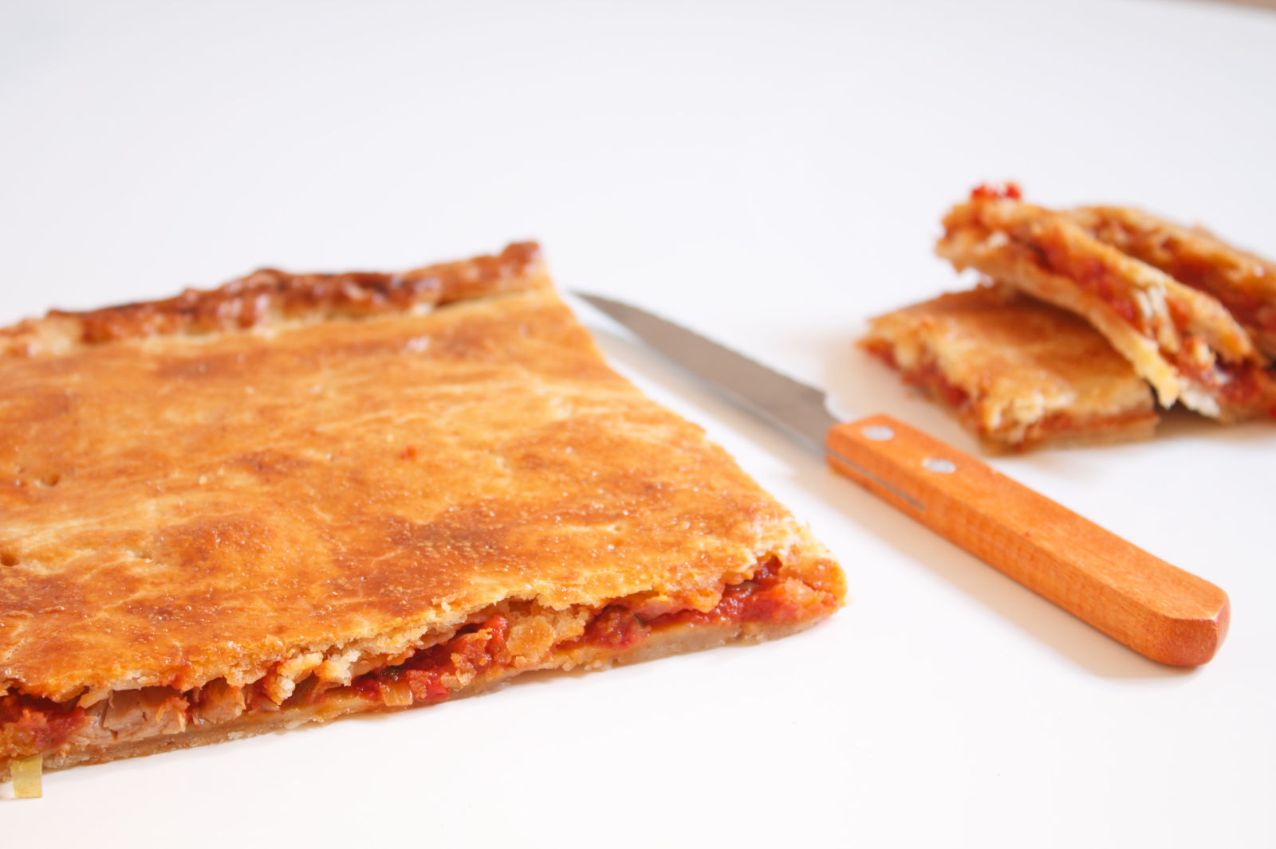
Coca farcida

One of the most popular recipes with different variations, which can be found in many ovens and bakeries all around the Region of Valencia. It is baked flour and oil dough stuffed with a delicious mixture of tomatoes, peas and tuna. Coca farcida is an ideal snack or a delicious entree.

Ingredients
1 kg. flour, 1/2 l. olive oil , 1/2 kg. onions, 1/2 kg. ripe tomatoes, 125 gr. dried tunny trunk, 250 gr. peas, 1 hard-boiled egg, 20 gr. salt, bicarbonate, olive oil.

Preparation
Mix the flour, salt and bicarbonate in a bowl. Pour in hot olive oil. If the mixture is too dry, add some boiling water.To prepare the tomato mixture, lightly fry the onion, tomatoes and add the peas and the shredded tunny. The dried tunny trunk should be desalted previously for three hours, changing the water continually. When the mixture is properly fried, add the hard-boiled egg in small pieces. Spread a layer of dough over a pre-greased tray. Spoon on the tomato mixture and cover with another layer of dough. Bake in the oven until golden brown.

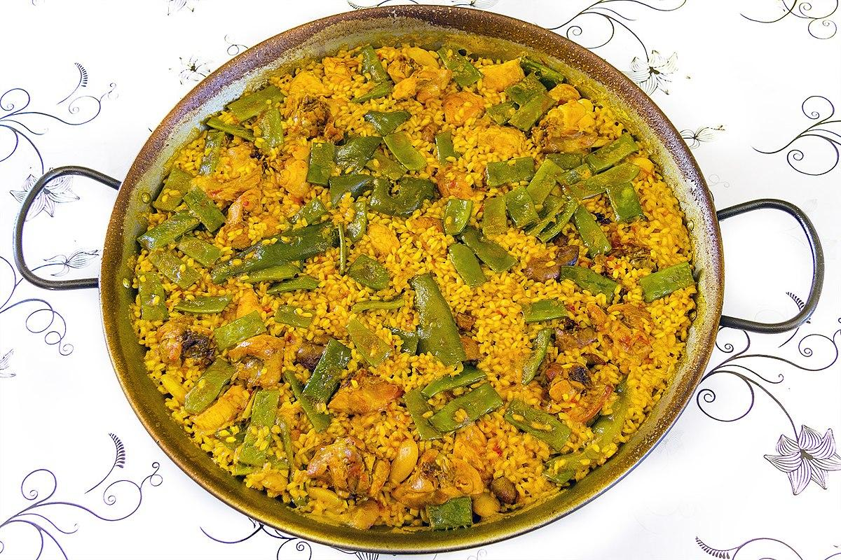
PAELLA

Paella is the greatest symbol of Valencian cuisine and probably Spanish gastronomy as well, famed throughout the world. Its origin, like all humble dishes, comes from the combination of ingredients readily available to families, especially from the Valencian countryside, which provided fresh vegetables. It was also common for families to raise their own chickens and breed rabbits, and so given the abundance in which rice crops are grown in La Albufera, the result is this authentic Valencian dish named after the pan in which it is cooked.Ingredients
400 gr. Rabbit, 700 gr. Chicken, 300 gr. Green beans, 100 gr. Tavella, 200 gr. broad beans, 1 ripe tomato, 400 gr. Rice, D.O.Valencia, 8 spoonfuls of oil, a pinch of paprika, saffron and salt.

Preparation
Heat a paella dish and add the oil, once this is hot add the meat cut up into pieces, fry it well and then add the green beans, the broad beans and the tavella. Continue to lightly fry this for about eight minutes and then add the grated tomato, when this is fried add the paprika and, without letting it burn, add water up to the rim of the dish. Leave it to cook for 30 minutes and add salt to taste. When the broth reaches the remaches add the rice and spread it round the dish, add the saffron and leave it to cook for a further 17 minutes. Leave it to sit for a few minutes before serving.

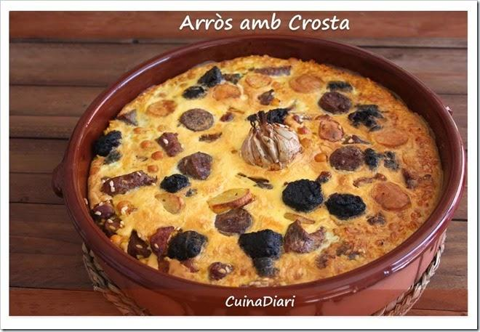
Arròs amb costra

Arroz con costra (literally meaning ‘rice with a crust’) is a traditional dish from the south of the province of Alicante, though it is also prepared in a number of towns and villages in the north of the province.
The recipe contains rabbit and/or chicken, as well as local sausages – such as longaniza blanca and longaniza roja, butifarrón and blanco – which are cooked together with the rice in a clay dish. What makes this dish unique, however, is the beaten egg that is added on top when the rice is almost ready. When cooked, this forms a soft layer that is known as the costra or crust. Traditionally, a costrera is used to cook the egg. This metal implement sits on top of the dish and is filled with embers from the fire, preparing the costra so it doesn’t need to go in the oven.

Ingredients
- Rice (100g per person)
- Water (double the amount of rice, one glass of water = 200g)
- Extra virgin olive oil (160ml)
- 18 eggs
- Meat cut into pieces (1kg): the dish is made with either rabbit, chicken or both. You can also use pork ribs, though this is less common.
- Longaniza blanca and longaniza roja (3 of each type of sausage)
- Blanco (a type of sausage) (4) and butifarrón (4)
- Cooked chickpeas (300g) (optional)
- Grated tomato (500g) (optional)
- Saffron
- Salt

Preparation
Heat the oil in a paella dish or pan and fry the longaniza blanca and longaniza roja which have been cut up into 3cm pieces. Remove from the pan and place to one side. Fry the blanco and then the butifarrón (separately, as they have different cooking times) and place with the longaniza. Salt the meat and fry until golden brown. Place in a clay dish. Fry the tomatoes and chickpeas (optional) in the pan using the same oil. Add the mix to the clay dish with the meat and place over the heat. Add the water and bring to the boil. Check the salt, add the saffron and rice, distributing it evenly across the dish. Next, add the sausages which you have set aside. Cook until the rice is ready, gradually reducing the heat. When the rice is cooked, add the beaten egg on top. Finish cooking in the oven or place the costrera on top. Leave to rest for a few minutes before serving.

All i Pebre. Traditional recipe Valenciana
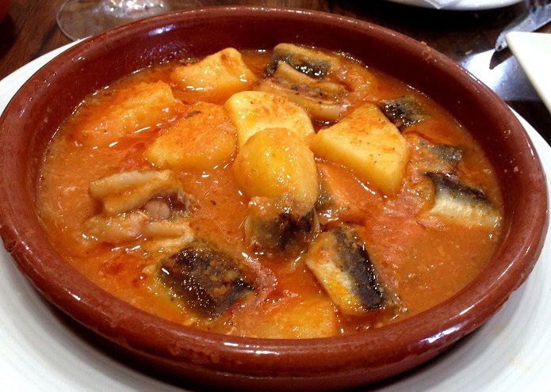
The all-i-pebre is a typical Valencian dish, which means Castilian garlic and paprika. The origin of this recipe is situated on the banks of the lagoon located just ten kilometers south of the city of Valencia, where once were abundant eels and so, is the main fish of this dish.
If you want to taste this delicacy Valencia in your house, here you have the recipe:
Ingredients for 4 people:
- 1 kg of eels
- A teaspoon of saffron or food coloring
- 1.5 dl oil
- 50 g of onion
- 50 g flour
- Sweet paprika (tablespoon)
- 1 chili pepper (or more if you like spicy)
- 3 or 4 cloves garlic
- 1 small slice of toast
- 12 almonds
- A little Parsley
- Salt to taste
- ½ liter of water

Preparation:
First wash the eels with cold water and clean them well, first we cut the heads and then the tips of the tails. After the return to wash and dry them with a cloth.
Once clean and when they had removed the excess moisture, cut into pieces of approximately 6 centimeters. Reserve.
On the other hand, in a mortar we crush the garlic. Reserve. Then we chop the onion.
In a casserole put oil to heat, when warm, put the garlic and brown them. Once they are beginning to be incorporated onion. Mix and immediately incorporate the flour and paprika, stirring.
When it mixed incorporate water and saffron or dye and let it boil.
When it begins to boil incorporate the Eels. Eels must be not completely covered by water. Add the chilli and add salt
Let cook for about 15 or 20 minutes.
Five minutes before the end of cooking, almonds, parsley and toast, which was previously crushed in a mortar is added.
In some locations in Valencia, all i pebre Eels is accompanied with sliced potatoes, if you want to make incorporating stew, will have to cut into irregular pieces and not very large, and incorporated by the water at the beginning of the recipe.
There are several versions of this recipe because unfortunately not yet have an official certification as with Paella. And we are sure that wherever faithful to that offered in the Albufera, place of origin, will be delicious.

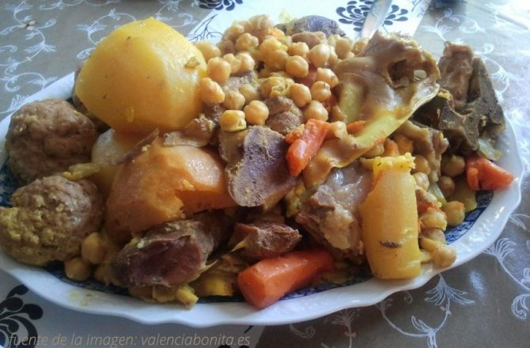
Putxero
When it comes to healthy Spanish comfort food, puchero is about as good as it gets. Puchero is a type of Spanish stew that varies from region to region and, of course, from house to house.
It is basically a type of “cocido,” which is a stew made from various meats, bones, and vegetables which may also include legumes and potatoes. Where in some regions the focus is on garbanzos and sausages, here in the Valencian community more focus is placed on the variety of meats and vegetables.
A basic puchero consists of broth obtained from a variety of meats and vegetables which is usually served first either alone or with rice or fine pasta noodles as a soup. The broth is followed by a large platter with all of the meat and vegetables which is placed in the center of the table and from which everybody can serve themselves.
It is meant to be a simple yet complete meal that brings the entire family together.
It’s hard to formulate a puchero recipe because it does vary so much. Even in the Valencian Community, puchero can vary from house to house, but you can buy pre-prepared trays of meats and vegetables at most supermarkets marked that they are meant for puchero, which gives you a fairly good idea of what most people use.
The basic puchero usually uses beef bones (with a bit of meat still attached) mixed with some pork bones, a piece of beef for stewing, a bit of chicken or “hen” meat or both. It is said that hens, after they have finished laying eggs, have a much less tender meat which is perfect for giving flavor to stews like puchero. They also include a square of “tocino” also known as pork fatback, and usually add in a “pilota” or two (or three). The pilota is basically a big, oval meatball, the size of an ostrich egg, made with ground pork; it is cooked along with all of the other meat and vegetables. Here you can buy them premade and ready to cook in your puchero, but you can also easily make your own just as you would any other type of meatballs. I’ll probably eventually share a recipe here on the blog. Some people add in some sausages such as blood sausage, but I don’t.
As for the vegetables, puchero usually uses a mix of green vegetables and root veggies like parsnips, turnips, rutabagas, and carrots. They add in some celery and leeks for flavoring the broth, and some “cardos” or “pencas” which are the tough leaf stalks of the artichoke thistle plant; those are my favorite greens for eating along with the beef. Usually potatoes and boniato are added in, along with some garbanzos, but I usually just use the boniato which I happen to love. That keeps my puchero paleo and just the way I like it! If you can’t find boniato, you can use any type of sweet potato instead!

I love making puchero because it is such a hearty, well balanced and nourishing meal. I also love that despite the fact that the idea of “low fat” being healhty has taken force here in Spain, most people aren’t afraid of the fat from the tocino (pork fatback) and they mash it into the potatoes or boniato the way many Americans mash in some butter.
Puchero is a great meal for holiday get togethers, which makes it perfect for Christmas dinner. We usually eat it here on Christmas day accompanied by the leftovers from Christmas Eve.
Another interesting thing to note is that most people make more broth than they will need and save it for making “arroz al horno” afterwards. Those who throw garbanzos into the mix also can save some of those for their rice the next day.

