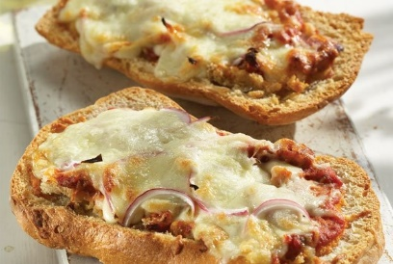

# **Ciabatta pizza with haloumi and village sausage**

**Ingredients:**

• 1 loaf of ciabatta

• 2 tbsp. olive oil

• 1 large (or two small) village sausage

• 4 tbsp. tomato sauce (ready)

• 100 gr. grated mozzarella

• 100 gr. grated halloumi

## **Steps to Make It:**

* First we cut the ciabatta horizontally with a knife and divide it into 2 pieces.
* Brush it with a little olive oil.
* Divide the tomato sauce into 2 pieces of ciabatta.
* We sprinkle with cheese, onion slices and, finally, spread the sausages evenly, cut into slices.
* Finally, we bake in the oven at 200 ° C on the heating elements for 15΄, until the cheeses melt and the ciabatta is crispy.

# **Ciabatta pizza with haloumi and village sausage**

**Ingredients:**

• 1 loaf of ciabatta

• 2 tbsp. olive oil

• 1 large (or two small) village sausage

• 4 tbsp. tomato sauce (ready)

• 100 gr. grated mozzarella

• 100 gr. grated halloumi

## **Steps to Make It:**

* First we cut the ciabatta horizontally with a knife and divide it into 2 pieces.
* Brush it with a little olive oil.
* Divide the tomato sauce into 2 pieces of ciabatta.
* We sprinkle with cheese, onion slices and, finally, spread the sausages evenly, cut into slices.
* Finally, we bake in the oven at 200 ° C on the heating elements for 15΄, until the cheeses melt and the ciabatta is crispy.