Ciabatta pizza with haloumi and village sausage
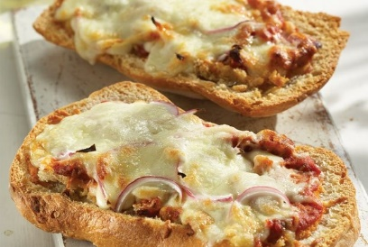

Ingredients:
• 1 loaf of ciabatta
• 2 tbsp. olive oil
• 1 large (or two small) village sausage
• 4 tbsp. tomato sauce (ready)
• 100 gr. grated mozzarella
• 100 gr. grated halloumi

Steps to Make It:
- First we cut the ciabatta horizontally with a knife and divide it into 2 pieces.
- Brush it with a little olive oil.
- Divide the tomato sauce into 2 pieces of ciabatta.
- We sprinkle with cheese, onion slices and, finally, spread the sausages evenly, cut into slices.
- Finally, we bake in the oven at 200 ° C on the heating elements for 15΄, until the cheeses melt and the ciabatta is crispy.

